**Experiment No: 01**

**Experiment Name:**

(i)A program to insert an element from a specific position of an array.

(ii)A program to delete an element from a specific position of an array.

(iii)A program to update an element from a specific position of an array.

**Objectives:**

To study and write program and check its results about insert,delete and update an element from an array.

**Pseudo Code-1:**

#include<stdio.h>

main()

{

int i,j,v,n;

printf("Enter the element number \n");

scanf("%d",&n);

int ara[n];

printf("Enter %d element \n",n);

for(j=0; j<n; j++)

scanf("%d",&ara[j]);

printf("Enter insert position\n");

scanf("%d",&i);

printf("Enter the insert value\n");

scanf("%d",&v);}

if(i>=n)

{

ara[n]=v;

}

else

{

for(j=n; j>i; j--)

ara[j]=ara[j-1];

ara[j]=v;

}

printf("Resultant array is\n");

for(j=0; j<n+1; j++)

printf("%d ",ara[j]);

}

**Result-1:**

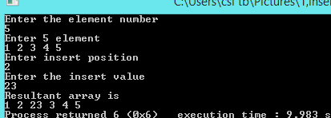

**Pseudo Code-2:**

#include<stdio.h>

main()

{

int i,j,n;

printf("Enter the number of element\n");

scanf("%d",&n);

int ara[n];

printf("Enter %d value\n",n);

for(j=0;j<n;j++)

scanf("%d",&ara[j]);

printf("Enter the delete position\n");

scanf("%d",&i);

if(i>=n)

printf("Delete is not position\n");

else{

for(j=i+1;j<n;j++)

ara[j-1]=ara[j];

printf("The resultant array is\n");

for(j=0;j<n-1;j++)

printf("%d\n",ara[j]);

}

}

**Result-2:**

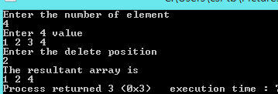

**Pseudo Code-3:**

#include<stdio.h>

main()

{

int i,j,v,n;

printf("Enter the element number \n");

scanf("%d",&n);

int ara[n];

printf("Enter %d value\n",n);

for(j=0;j<n;j++)

scanf("%d",&ara[j]);

printf("Enter update position\n");

scanf("%d",&i);

printf("Enter the update value\n");

scanf("%d",&v);

if(i>=n)

printf("Update not possible\n");

else

ara[i]=v;

printf("Update array is\n");

for(j=0;j<n;j++)

printf("%d\n",ara[j]);

}

**Result-3:**

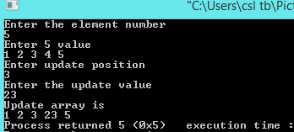

**Discussion:**

From study about insert,delete and update any element from an array,i will know how can I do it .First I write an algorithm,then I write those program according to it.In insert,I can insert any element from the array,but if the insert position is greater than array size it inserted last index of the array.In delete if the delete position is greater than array size ,it will not possible.And in update, if we inputed update position is greater than array size ,update will not possible.